Supporting and enabling equitable early learning and childcare provision for children with profound and multiple learning disabilities
Case Study | Indigo Early Years – Castlemilk
The Indigo Childcare Group is a social enterprise that exists to empower families to overcome poverty and its challenges through the provision of affordable, innovative childcare services for children aged 6 weeks to 16 years old.
The Indigo group (Indigo) is committed to supporting high-quality and inclusive practices across its four types of service: Early Learning and Childcare (ELC), School Aged Childcare, Youth Services and Mobile Creche.
‘Inclusion’ for Indigo means that all children have equal access to and can participate fully in the services.
Gag

  - This case study highlights the inclusive approaches, vision and values embedded in Indigo. In particular, how equitable experiences are supported for children with profound and multiple learning disabilities (PMLD) to access high-quality Early Learning and Childcare.
  - Indigo operates two ELC settings in Glasgow; Castlemilk and Garrowhill. This case study focuses on Castlemilk; a state-of-the-art provision based within John Paul II Primary School, catering for children aged from 6 weeks to 5 years old. It provides a bright and stimulating environment for children with access to outdoor spaces.
  - Castlemilk sits within an area of multiple deprivation and aims to close the poverty-related attainment gap by providing high-quality early learning and childcare for the community they serve.
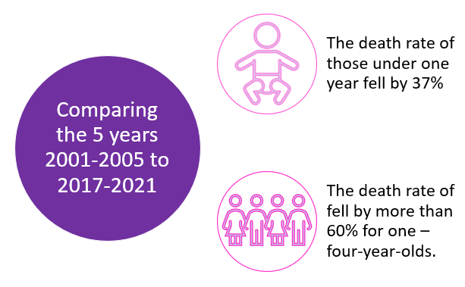
  - ,Over the last 20 years, the life expectancy for many life-shortening ‘childhood’ conditions has changed significantly. As a result, more children with rare, complex, and life-threatening conditions are now surviving later into childhood or adulthood.
  - In March 2023, Indigo Childcare Group and The Scottish Centre for Children with Motor Impairments published a report examining the provision of Early Learning and Childcare for children with the most complex disabilities and needs. The report highlights barriers encountered by the families of children with complex disabilities and intensive health care needs in accessing statutory ELC provision across Scotland; and includes recommendations to achieve inclusive ELC practice that meets the needs of all children.
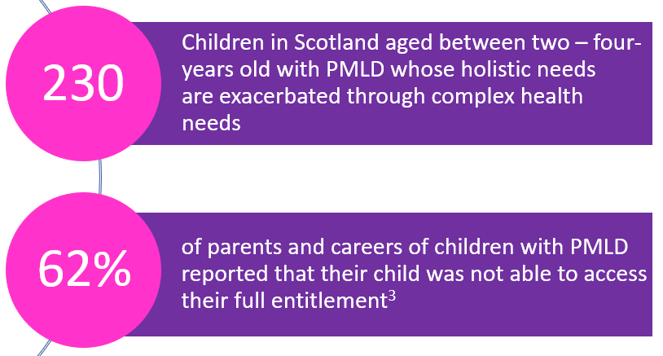
  - Inclusive and welcoming provision
  - Indigo’s ambitious Inclusion policy is simple: Improve outcomes and support the wellbeing of children and young people by offering the right support at the time from the right people. The policy and associated action plan support staff to work towards the aspiration of inclusion.
Every member of staff at Indigo is responsive to the individual needs of each child, and this carries through to the provision in Castlemilk. It welcomes children of all abilities, where they learn through play with their peers and are supported by knowledgeable staff who, over the years, have supported and provided equitable experiences for children with complex needs such as Aicardi Syndrome, a Chromosome Deletion Syndrome and Spina Bifida, and go above and beyond to support the needs of every child by reducing or eliminating barriers for learning and to fully engage in experiences with their peers.
  - Environment is as important as the staff who fill it. Castlemilk has three integrated playrooms; babies-two-years-old, two–three-years-olds, and three-five-year-olds. All playrooms benefit from direct access to three separate garden areas and a large shared vegetable patch, with a wooden climbing frame that was designed and built by a parent. Keyworkers also ensure that electronic home link diaries are updated with photographs and a description of learning daily, along with home activities to support the consolidation of learning for children.
  - Adaptations and strategies are specific to each child and where possible are identified before children join the setting. Indigo has an enhanced transition process in place (where required). On some occasions, this starts months in advance of enrolment to ensure that the full staff team have the knowledge and training required to fully support children and families during the transition to nursery and throughout their time in the nursery.
  - Enhanced transition process in practice
  - In 2022, the setting welcomed a young boy with Downs Syndrome into the nursery. The relationship with this family was established when his older sibling attended the nursery. Concerned about not being about to return to work as a teacher, Mum contacted the setting when he was only one day old to enquire if they would be able to support him. The setting immediately offered reassurance that this was not a barrier and that they would work with the family to understand his needs before he joined the setting.
  - During the first few months, the setting kept in regular contact with the family and received updates on any medical interventions. Soon after, the setting met with the parents to make plans for their child to transition into nursery. An enhanced transition was put in place, with staff undertaking training in NG tube feeding, pump feeding and oxygen training to support his specific needs.
  - By the time the young boy started in the setting, the team were well equipped and confident that they were able to support the family. They also work closely with the young boy’s Physiotherapist, Occupational Therapist and his Speech and Language therapist (SALT) who visit the nursery regularly. The setting was recently provided with a standing frame. This has created endless opportunities for him, such as allowing him to stand beside his peers during experiences whilst strengthening his muscles.
“I am delighted to say that Indigo have excelled and exceeded all our expectations. They undertook training for oxygen, NG feeding and had training from Down syndrome Scotland. They have welcomed [child] with open arms and he is as happy as can be in Indigo.”
  - Recognising and sharing best practice
  - The Early Years Manager also chairs Inclusion Support Group meetings for the South of Glasgow which brings together Early Years settings from across the city to discuss additional support needs within their own services and share good practice, knowledge and experience.
  - Indigo won the Working with Parents category at the 2023 Nursery World Awards. The Nursery World Awards celebrate best practices across the early years sector.

As part of Indigo’s Family Matters service, the Loving Language strand offers support for children and their families in speech, language and communication. This became a particular focus following the lockdown, and in response to the speech & language needs of children were changing. The Loving Language programme builds on existing quality work in raising attainment, inclusion, trauma-informed practice and whole family support to improve the language and communication skills of all children.

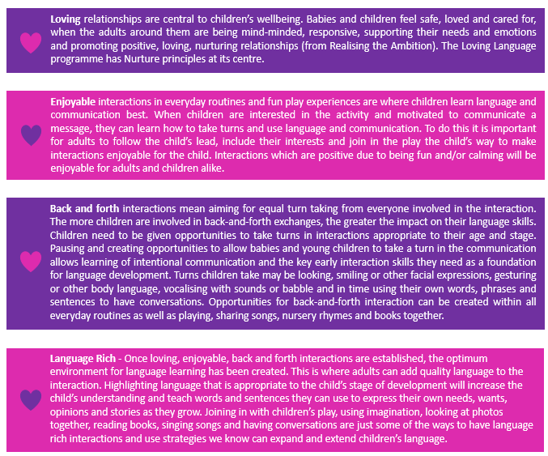

Since the introduction of Loving Language, 89% of Indigo practitioners report feeling more confident in understanding the strategies that can be used to support children and families with speech, language and communication development and what to do when a potential delay is identified. Families and practitioners have also been able to identify concerns quicker, and as a result have been able to introduce appropriate support strategies earlier, resulting in 83% of children meeting their milestones with the remainder mostly being children with a diagnosed developmental or congenital delay.

Innovative initiatives across Indigo Childcare Group
  - Some specific examples of speech, language and communication initiatives embedded within Indigo include:
- The full staff team are trained in Hanen Teacher Talk, Embedding Learning, Providing Self-Reflection Tools, Adapting Planning Paperwork, and Measurements and Integrating into 1-1 discussion.
  - This training helps reinforce the importance of bringing parents on the speech, language and communication journey to maximise the impact of early interventions for children.
  - A Hanen training programme for parents will be incorporated into the transition programme in AY 23/24.
The Hanen Teacher talk programme supports practitioners and families in the wider community, not just Indigo. Practitioners from across the community have participated in the Hanen Teacher Talk training and families from across the community have attended the wide range of support services. Unless this work happens at community level, Indigo recognises that the systemic change needed is less likely to be achieved.
- Targeted speech, language and communication interventions with smaller groups of families (including Language Land, ICAN Early Years Toolkit, Attention and Listening Activities, and Makaton)
  - An extensive range of communication skills have been developed for 30 targeted pre-school children. This includes concentration, listening, auditory discrimination, cooperative/ symbolic play, comprehension, vocabulary, sentence use, peer interaction, and speech sound intelligibility and talking confidence.
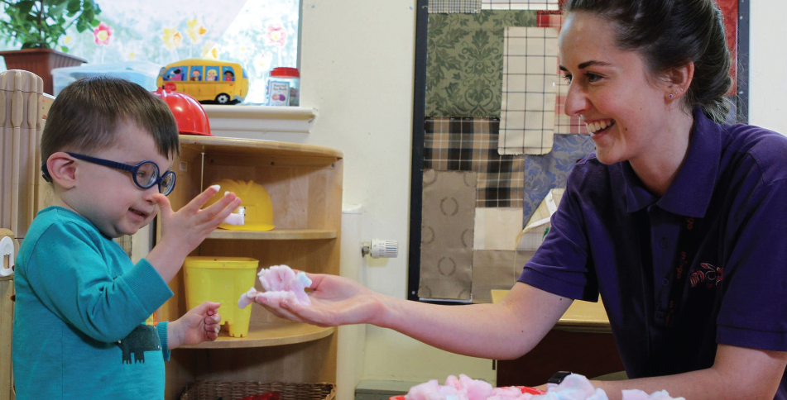
An Inclusion Coordinator role was created at Indigo to support children, young people and their families who have a recognised need for additional support. The role is not specific to working with children or young people who have a diagnosis, the leadership and coaching aspect of this focuses on upskilling the team around the child, including children experiencing emotional, and behavioural challenges and looking after children/young people. Initially, this role was simply a couple of extra hours per week in a part-time role. With smart rota planning, this was gradually built up to a full-time role. Due to rota planning, most of the additional hours are not additional, and as a result, there was not a significant financial impaction attached to the role.
The Inclusion Coordinator works across all Indigo services to:
- Support staff develop and embrace the inclusion policy.
- Inform and contribute to practice development.
- Review care plans.
- Develop strategies to communicate with parents and their children.
- Attend enrolment meetings that may require an inclusive approach, and
- explore parents' support, training and parental discussions.
Since coming into post, the Inclusion Coordinator has also developed an inclusion library which is accessible to all and contains a wide range of resources that support a wide range of needs; and was funded through the inclusion support fund.
This resource was beneficial in supporting a child who was having trouble regulating emotions, and who was becoming aggressive towards other children and staff. By utilising the resources available within the inclusion library, the Inclusion Coordinator and Keyworker were able to support the child to regulate his emotions by working together in a small group. The ongoing, consistent approach from his Keyworker and, the wider team resulted in a positive outcome for the child. At a follow-up visit, the Inclusion Coordinator was delighted with the amount of progress, as was his family.

Key Messages

- A foundation of a culture of inclusion, where everyone understands and supports a child’s right to accessing funded ELC, is crucial for consistency.

- A dedicated inclusion policy and action plan supports staff working towards the aspiration of inclusion.
- An enhanced transition process ensure staff have the appropriate knowledge and skills required to meet the individual needs of all children.
- Close links and partnership working with a range of specialists and professionals produces outstanding results.
- A child’s needs are not always best met by attending a specialist ELC provision.
- There are real benefits when parents and families are engaged in their child’s learning and development.



National Records of Scotland Vital Events Reference Tables 2021. 2 Overview of the provision in Scotland of early learning and childcare for children with profound and multiple learning disabilities with a life-limiting of life-threatening condition report.

